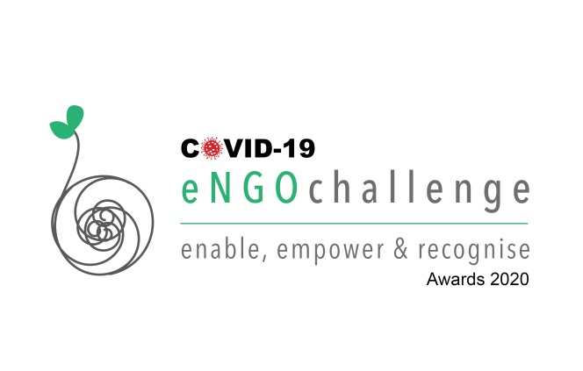
NOMINATION GUIDELINES
- The form must be complete in all respects. Incomplete forms can be subject to rejection
- We recommend you to go through the guidelines before filling up the nomination form.
- Kindly use one primary email address throughout the nomination process to ensure smooth flow of information both ways.
- Applicant is required to attach one demo PPT presentation and a small demo video of 30 – 60 seconds about the project/initiative with this nomination form. If you fail to do so the Jury has all rights not to consider your application.
- Applicant can edit their form till the last date of nomination even after submitting the application.
- Attachments should not be more than 2 MB
JUROR'S EVALUATION CRITERIA
The evaluation will be based on Impact, Innovation, Replicability, Sustainability, Scalability and Participation. To bring about transparency in the assessment process, there will be three tier assessment processes.
Before filling up your application, please go through the following evaluation criteria that the Jury will take into consideration to assess your application:
- Content & Services: Quantify the quality of content and services delivery, relevance of content and its utility value.
- Impact, accessibility & Sustainability: Quantify and qualify the social impact & sustainability of your initiative.
- USP & Strategic Value: Please focus on the uniqueness of the idea & easiness of strategy replication.
- Benefit & Utility: Please describe the real benefit to the last mile users and society.
NOMINATION FORM
Organizations Details
1. Organisation's Name*
2. Contact Person*
3. Mobile Number*
4. Mobile Number*
5. Organisation’s Postal Address*
6. Email ID*
7. Organisation’s Key Areas of Work*
City, State and Country Details
1. City*
2. State*
3. Country*
4. Postal Code*
Nomination Category *
Select Category Name and Highlight

- Innovation@Covid-19 Communities | Covid-19 | Technology | Health | Finance
- Environment & Sustainability Agriculture | Green Technologies | Sustainable Solutions
- Governance & Livelihood Public Administration | Entitlements | Citizen Services
- Digital Empowerment & Tools ICT I Social Media I Web & Internet I Crowdsourcing
- Education & Learning Life Sciences | Capacity Building | Skill Development
- Heritage & Culture Civilisation Art | Tourism | Culture | Heritage | Language | Folk | Music Practices
- Entrepreneurship & Outreach Start-ups | Promotion | Marketing | Sustainability
- Healthcare & Wellness Services | Medicine | Lifestyle | Sports
- Enablement & Empowerment Gender Equality | Senior Citizens | Women Empowerment | Differently Abled | Inclusion | Minority| Community
Project/Initiative Details
1. Title of the initiative*
2. When did the initiative start*
3. When did the initiative start*
4. Languages the initiative/organisation caters to
5. Geographical reach of the initiative/organisation *
6. Brief description of your organisation/initiative * (Explain the vision and model in less than 200 words)
7. Uniqueness * (What is the special about the initiative? Why did you decide to take up this initiative? How has it helped and impacted the society?
8. Impact & Achievements * (list upto 10 impact points of the initiative since its commencement (Case studies,Awards received by initiative, mention external/internal monitoring and evaluation studies)
9. Challenges faced to start or execute the initiative? How were they overcome? *
10. Is the initiative sustainable? Is yes, please explain the sustainability approach. *
11. How many beneficiaries have been reached by initiative/org
12. List some key achievements of the organisation in the last two years. *
13. Have you ever applied for any award organized by Digital Empowerment Foundation? If yes, please specify the name of the initiative, the organisation and the year. Also, mention if you were a Nominee, Finalist or Winner?
14. Links of your entire social media platforms used - Facebook, Twitter, Pinterest, Instagram, and LinkedIn? (Other digital platforms If using)
15. Supporting documents, if any * (You can share case studies, photos, research reports, organisation or initiative presentation. Files can be uploaded only in.doc, .docx, .pdf, .ppt, .pptx, and .swf format)
16. Video, if any * (.swf, .wmv, .vob, .mpg, .3gp, .mp4 format Only)
Head of Organisation
Initiative Manager
Funders
Please save the form with all details and email it to us at engochallengeaward@defindia.org along with necessary All attachments.

